UNIVERSITI TUNKU ABDUL RAHMAN

Lee Kong Chian Faculty of Engineering and Science

**ONLINE SHOPPING SYSTEM FOR ORGANIC PRODUCTS**

Presented By: Chok Kai Xian Supervised By: Ms. Farizuwana Akma Binti Zulkifie

Alertness of the devastation of organic materials has elevated the problem of environmental conservation. “Green consumerism”, an ecological consumption will then be built. There are more consumers have considered for greener products as they are more people interested to buy them. However, there are people who don’t know where to find and buy organic products and sometimes the organic shops aren’t open nearby their neighbor area so it is a waste of time and cost to visit the stores. A solution to the problem is to create a web-based online shopping system for organic products as it is available for 24 hours and save time for queuing as there is no crowd of people.

* Study the difference of the attitude towards online shopping system between organic consumers and inorganic consumers.
* Examine the existing feature used in the online shopping system and implement it in our system to fit with the needs of the organic products consumers.
* Develop the web application that consists of the feature and design required by the organic products consumers.

ABSTRACT

OBJECTIVES

RESULTS AND DISCUSSION

 

 

DEVELOPMENT TOOLS

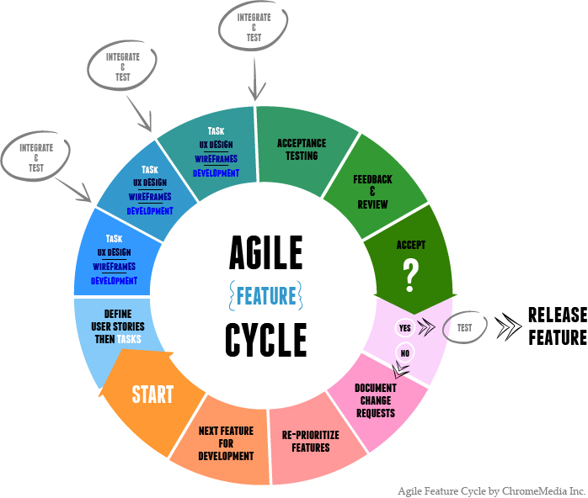

METHODOLOGY

**Web App**

Customer Site

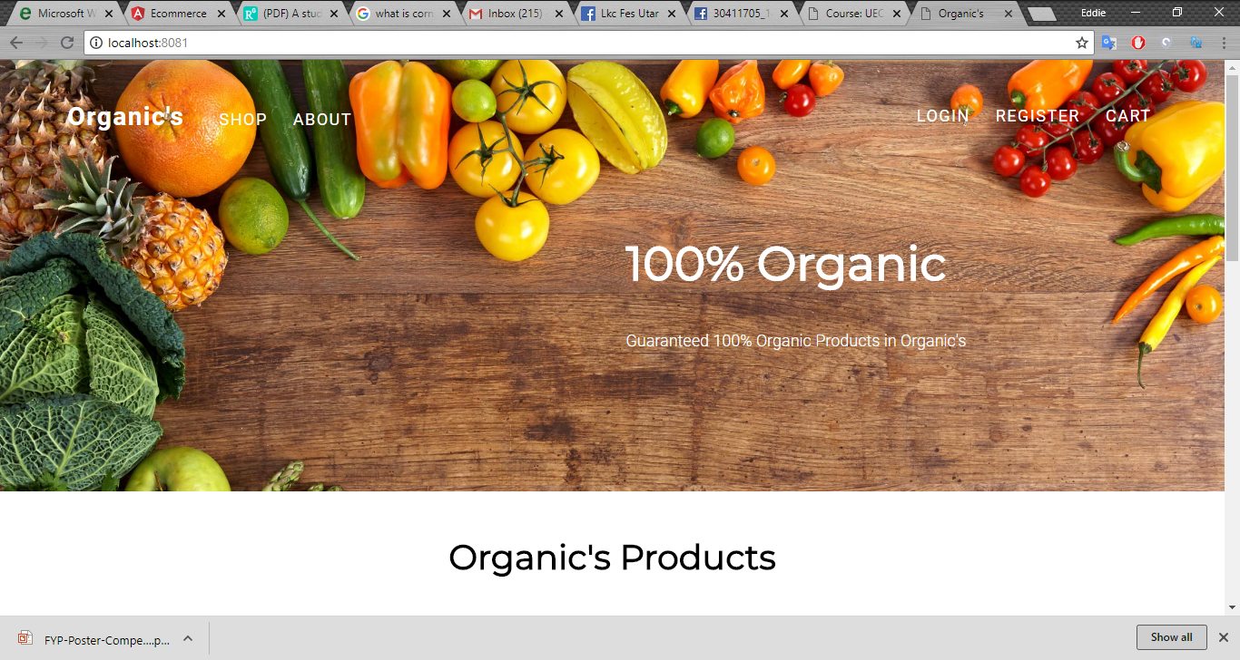

Admin Site

